Brain imaging studies of decision-making and action selection
VOLUNTEERS NEEDED FOR MAGNETOENCEPHALOGRAPHY STUDIES OF THE BRAIN

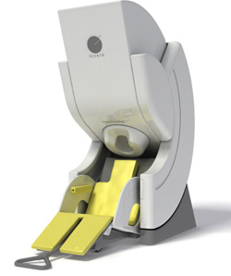 | 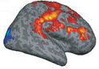

Magnetoencephalography (MEG) is a type of brain scan that allows us to see how the brain is organised, processes information and performs skills like speech or memory. This scan is safe and does not involve any needles or injections.

We are looking for healthy volunteers to improve our understanding of brain structure and brain function involved in decision making. This study would take one three-hour block of your time. You would be asked to sit still in a scanner and perform a simple decision-making task. You would also be asked to perform similar tasks outside of the scanner, and may also be asked to undergo a separate MRI scan to examine the structure of your brain.

Who are we looking for? Healthy fluent English-speaking men or women aged 18+ who are not pregnant. You will be asked questions about your medical history to check your suitability for the MEG session and the MRI scan.
If you are interested and would like more information please contact Lorenzo Mazzaschi at lorenzo.mazzaschi@psy.ox.ac.uk.

Thank you for your time!

